We hope you will join us for the
Elks of Canada National Convention
North Bay, ON
July 10 – 13, 2024

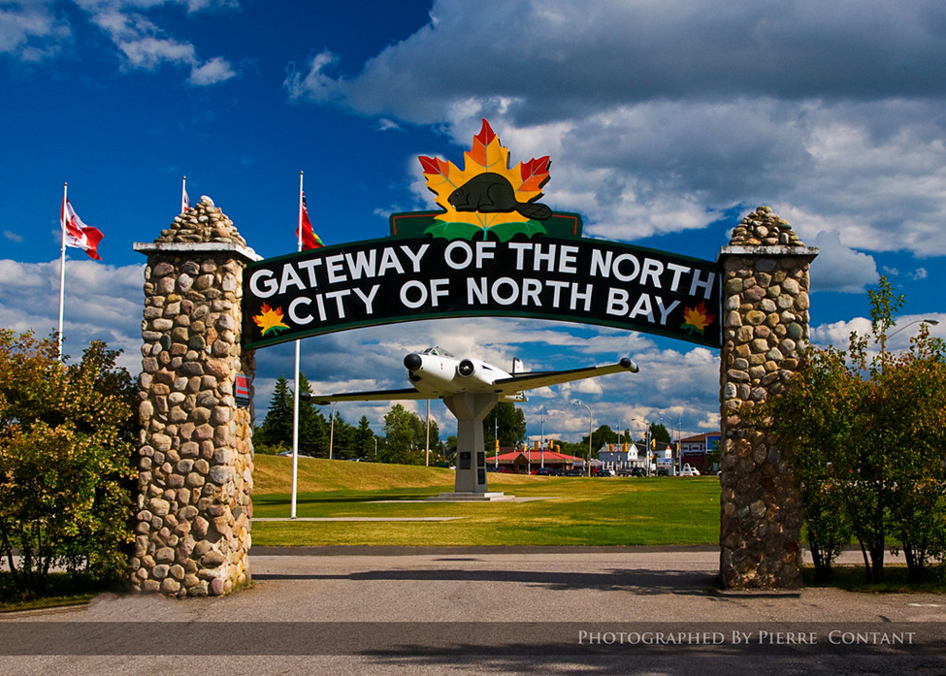

About this years Convention….
Location: North Bay, ON
Date: Arrival Wednesday July 10, 2024
Departure Sunday July 14, 2024
Host Lodge: North Bay Elks Lodge #25
Ontario Elks Association
Who is included: All members of the Elks of Canada may be delegates
Spouse, family or others welcome during dinners and entertainment. Prices listed below.
Convention Type: In Person and Virtual – Hybrid Model
Spousal/Guest Program: Experience Downtown North Bay including the Dionne Quints homestead.
Casino Day
Nature hike along North Bay Escarpment
Further details to follow. At own expense.
Transportation: Transportation available to and from Hotel and Lodge
Transportation available to and from Airport to Hotel.
What is included with this years Registration:

Wednesday July 10, 2024
- Registration 5:00 pm – 8:00 pm
- Drop in anytime BBQ (burgers, hot dogs, salads) 5:00 pm – 7:00 pm
Thursday July 11, 2024
- Morning and afternoon snack
- Lunch
- Dinner and evening entertainment
- Spousal/additional ticket cost is $30 per person.
Friday July 12, 2024
- Morning and afternoon snack
- Lunch
- Dinner and evening entertainment
- Spousal/additional ticket cost is $30 per person.
Saturday July 13, 2024
- Morning Snack
- Grand Ball Ticket and entertainment
- Spousal/additional ticket cost is $45 per person.
Sunday
- Departure day
Advance registration rate: $250.00
After June 1, 2024, rate: $275.00
Virtual Delegate rate: $25.00
Traveling to North Bay, ON

Via Plane: North Bay airport code is YYB.
If flying to North Bay, please check Air Canada. WestJet does not fly to North Bay. You will be routed through Toronto (YYZ). The only other airline that flies to North Bay is Bearskin Airlines

Driving: North Bay, ON is located 3 hours North of Toronto and just 3.5 hours West of the Nation’s Capital of Ottawa. Check Google Maps for the best directions.
Alternatives: Many people have asked about Flying into Toronto and renting a vehicle to drive to North Bay. North Bay is 3.5 hours from the Toronto Airport door to door in North Bay. The drive is beautiful right through the Muskoka’s - on a divided highway the entire journey.

Please contact us as we would be happy to help plan your journey to and from our Lodge.
Accommodations:
Hotel We have arranged preferred rates at the Fairfield by Marriott, a new Hotel close to our lodge.
2 Queen Room – $164
King Room - $174
King Suites - $184
(Rate subject to change)
Full Hot Breakfast available each morning & Hot Coffee 24 hours a day. Pool, fitness centre and lounge.
Social Space for Elks delegates and Guest at hotel
Specialized link available for booking hotels:
https://www.marriott.com/event-reservations/reservation-link.mi?id=1707509395855&key=GRP&app=resvlink
(705)-256-6784 – Quote Elks National Convention July 2024
RV Parking There are spaces for RV’s/Trailer to park directly on the Elks Lodge Property around the perimeter. Please note there are NO hook ups for Hydro or Sewer. We do have a hose that you could use to fill your City Water tank.

Campgrounds Within City Limits there are numerous campgrounds with partial and full hook up sites.
Registration form:
Name: ___________________________________________________
Home Lodge: __________________________________________
Home Province: __________________________________________
Mailing Address: _______________________________
_______________________________
Email Address: _______________________________
Phone Number: _______________________________
Special Dietary Requests:
____________________________________________________________________________________________________________________________________
Anything else? (Birthdays, anniversaries, special requests)
____________________________________________________________________________________________________________________________________
Registration: Are you a first-time attendee? _____
____ $250 In person delegate advance rate
____ $275 In person delegate after June 2nd, 2024
Guest/Spouse Program (Please indicate number of tickets needed beside each event)
____ $30 Thursday Dinner & entertainment
____ $30 Friday Dinner and entertainment
____ $45 Saturday Grand Ball Dinner and entertainment
Total Costs: ____________

Please Make payment payable the “Elks of Canada” and send directly to the Grand Lodge address – Attention Alma Mossing
Convention Booklet
We would love if you would consider providing an ad in our convention booklet as a member, business, or lodge. Booklets will be printed and given to delegates in person and sent Electronically to virtual delegates.

Booklet is 8 ½ by 11 – standard paper size, black and white print.

Business Card Ad (1/8 page) $50
¼ Page Ad $100
½ Page Ad $150
2/3 Page Ad $200
Full Page Ad $250

Please make payment payable to North Bay Elks Lodge. Email money transfers are welcome – but please email us first.

Email Ad details/logo to:

If you wish for our designers to design an ad for you please provide details of what you would like to include and we will do our best. Proofs will be sent back for approval prior to printing.
Deadline for ads in the Convention booklet is June 28, 2024
Need to know more about Convention or have a suggestion?

Visit our website at:

Email us at:
Elkslodgeconvention2024@gmail.com
Text:
Michael at (705)493-0069

Contact Grand Lodge:
Alma Mossing or Kevan McBeth
1-888-843-3557

402-2631 28th Avenue
Regina, SK S4S 6X3

grandlodge@elksofcanada.ca

